Architecture and zoning relevant factors

**Alleviate the range anxiety thanks to a good distribution of charging stations**

As shown in the current situation about architecture and zoning, the range anxiety is a key deterrent to the potential buyers of charging stations. The combination of slow and fast charging stations is the key to make the market thrive. In Japan, some studies have shown that there is a high correlation between the number of fast charging stations and the adoption of electric vehicles.

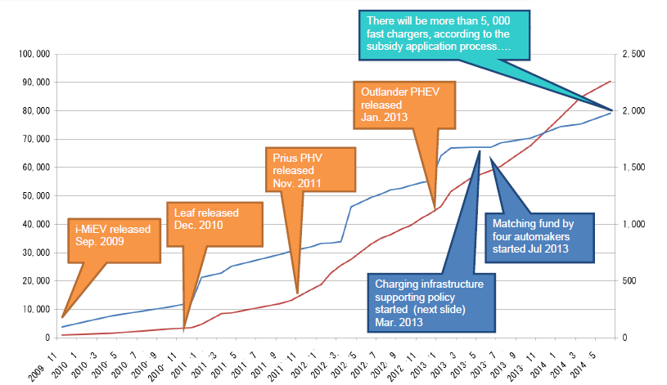

Number of cars accumulated (electrical and hybrid)

Number of fast chargers accumulated

Vehicles

Fast chargers

Correlation between fast charging stations and electric vehicles adoption in Japan

http://www.chademo.com/wp/wp-content/uploads/2014/10/Japan.pdf

The equipment of Tokyo-Nagoya highway with a dense network of fast charging stations managed to remove the range anxiety of electrical vehicle users. When 2 fast chargers were installed on this highway of a length of 350kms, only 20% of EV drivers dared to take the highway. After 7 units were deployed (one each 50km), the percentage of highway users doubled. An experiment (<http://chademo.com/pdf/characteristics.pdf>) conducted in Yokohama has shown that the distance coverage was low in the absence of fast charger, even if the range of the cars were sufficient. After the deployment of the fast charging station, the EV usage had dramatically increased, but the fast charger was only hardly used. These results show that it is not only the real range limitation that is a challenge, but also the users’ perception of their car’s range. Fast chargers can respond to this issue and are necessary to make long distance travels possible and enjoyable.

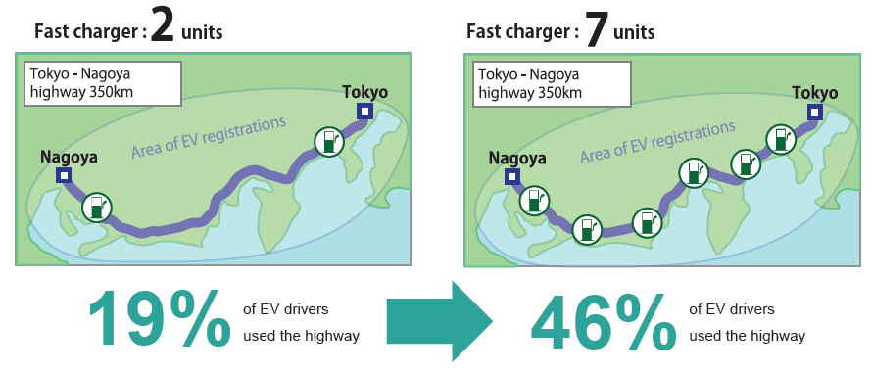

Improvement of highway coverage and its impact

http://www.chademo.com/wp/role/charging/

Even if the price of fast charging station is still high, the costs are rapidly decreasing due to economies of scale and an improvement of the technology. As Fuji low cost fast charging station reveals (see the part about CHAdeMO), a first step could be to produce fast chargers at lower cost, even if the charging time is a little longer, in order to get credibility and to permit a fast expansion of the electrical vehicle market.

However, in other countries like the United States, the use of slow chargers at home and work place are more developed compared to fast chargers, and it did not prevent the development of the EV market. On the contrary, as long as it is possible, installing chargers at home and at work is the simpler and most cost-effective way to target a big number of EV users. The market potential is more important, and the return on investment is easier to establish.

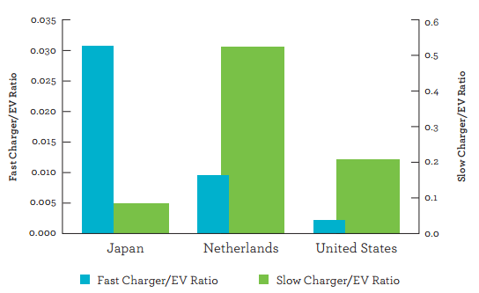

Different charging station deployment profiles, 2012

http://www.iea.org/publications/globalevoutlook_2013.pdf

A good marketing analysis is required to have an insight about the need of the different types of charging station in different countries. A good compromise between both types has contributed to a good development of the market in Netherlands and Norway.

**Guarantee international travel or long-scale travel through standardization**

Especially in Europe, the size of the countries and the multiple cross-border travels need to be considered. The compatibility between the different cars and chargers in the European countries need to be consistent. Following the standards is of paramount importance to be able to succeed in this market. With currently two existing standards for fast charging stations, and the lagging uncertainty about the result of this competition, it is recommended to propose fast chargers with both plugs in Europe at least.

**Quotes**:

**It is not only the real range limitation that is a challenge, but also the users’ perception of their car’s range**

**there is a high correlation between the number of fast charging stations and the adoption of electric vehicles**

or a small figure **: correlation of 0.9**

**it is recommended to propose fast chargers with both plugs in Europe at least**

**Layar**:

All the pictures with their respective links:

Picture 1 : http://www.chademo.com/wp/wp-content/uploads/2014/10/Japan.pdf

Picture 2 : http://www.chademo.com/wp/role/charging/

Picture 3 : http://www.iea.org/publications/globalevoutlook_2013.pdf

Sentence with “an experiment” (2nd paragraph) with the corresponding link : <http://chademo.com/pdf/characteristics.pdf>

References

Aoki, H. (2014). Best practices from Japan. 1st ed. [ebook] Munich: CHAdeMO association. Available at: http://www.chademo.com/wp/wp-content/uploads/2014/10/Japan.pdf [Accessed 3 Jun. 2015].

Chademo.com, (2015). Role of fast charging — CHAdeMO Association. [online] Available at: http://www.chademo.com/wp/role/charging/ [Accessed 3 Jun. 2015].

Characteristics of CHAdeMO quick charging system. (n.d.). 1st ed. [ebook] Available at: http://chademo.com/pdf/characteristics.pdf [Accessed 3 Jun. 2015].

Global EV outlook. (2013). 1st ed. [ebook] Paris: International Energy Agency. Available at: http://www.iea.org/publications/globalevoutlook_2013.pdf [Accessed 3 Jun. 2015].